TABLE OF CONTENTS
1 Introduction 1
1.1 Document overview 1
1.2 References 1
1.2.1 Project References 1
1.2.2 Standard and regulatory References 1
2 Software Architecture overview 2
3 Software design description 2
3.1 Component 1 2
3.1.1 Component interfaces 2
3.1.2 Component design description 2
3.1.3 Workflows and algorithms 2
3.1.4 Software requirements mapping 2
3.2 Component 2 2
3.2.1 Component interfaces 2
3.2.2 Component design description 2
3.2.3 Workflows and algorithms 3
3.2.4 Software requirements mapping 3
3.3 Component 3 3
3.3.1 Component interfaces 3
3.3.2 Component design description 3
3.3.3 Workflows and algorithms 3
3.3.4 Software requirements mapping 3
4 COTS – SOUP identification 3
5 Critical Requirements 3

Introduction

You may have all the description of the design of your software in a single instance of this document or have the design of each component/package/element in many instances of this document. This is your choice, which depends on the size of your software.

This section should provide an overview of the package and address at least the following issues:
- What this package is intended to allow the user (or different classes of users) to accomplish.
- Within reasonable bounds, what this package is not intended to allow users to accomplish.
- The application domains where this package is most likely to be of use.
- A high-level overview of how the package meets its requirements (which should have been documented elsewhere). This is to include relevant material from the "features" section of the cover sheet (the cover sheet is a wrapper doc with links to all other package docs).
Also worthy of treatment in this section:
- When applicable, a careful demarcation between the functionality of this package and others which - at least superficially - appear to address the same requirements.
Note: it's entirely possible that a discussion of what a package is not intended to do differs from a discussion of future improvements for the package.

Document overview
This document describes the design of XXX component/package/element of XXX device, part of XXX software development project.

References

Project References

# | Document Identifier | Document Title
[R1] | ID | Javadoc

Standard and regulatory References

# | Document Identifier | Document Title
[STD1] |  | Add your documents references.  One line per document

Add the standard references to the table above. It may include ISO 14971, ISO 13485, IEC/TR 80002-1, IEC 62304, amongst others.

Software Architecture overview
Describe here the top level software components and their interactions/relationships.
Use UML package diagrams and/or layer diagrams and/or interface diagrams.
Describe also the operating systems on which the software runs.
You may reference the system architecture document, if you have one in your project, which already explains the software architecture.

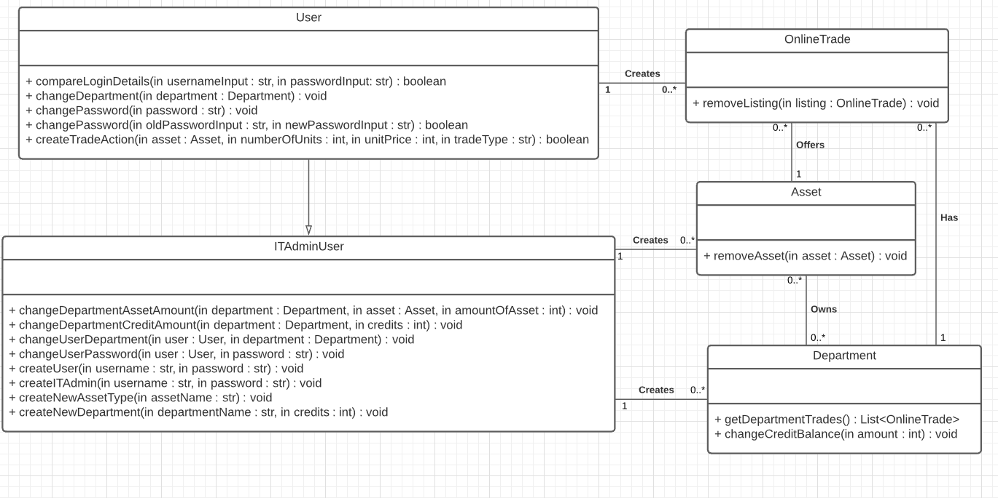

Software design description
If you have a single design document, describe each top level package/component of your software and if necessary sub-components/sub packages.
If you have one design document for each top level package/component, describe the content (sub components, sub packages) of each top level package/component.

Use Class diagrams, Collaboration / sequence diagrams, Deployment diagrams to illustrate your description.

Component 1

User Interface
In this section, discuss user interface issues and pages to be built; you can organize by the expected classes of users. These may include:
- Developers
- OpenACS administrators (previously known as site-wide administrators)
- Subsite administrators
- End users
You may want to include page mockups, site-maps, or other visual aids. Ideally this section is informed by some prototyping you've done, to establish the package's usability with the client and other interested parties.
Note: In order that developer documentation be uniform across different system documents, these users should herein be designated as "the developer," "the OpenACS-admin," "the sub-admin," and "the user," respectively.
Finally, note that as our templating system becomes more entrenched within the OpenACS, this section's details are likely to shift from UI specifics to template interface specifics.

Component interfaces
Describe the interfaces of the component and input output data

Component design description
Describe the design of the component, Use package diagrams and/or class diagrams to show the links between sub-components/sub-packages and or classes inside the component.

Workflows and algorithms
Use collaboration diagrams and/or sequence diagrams to show the workflows of components/packages/classes inside the component.
Describe algorithms, if possible. An algorithm may be described outside this document, in this case, add the reference to that document.

Software requirements mapping
Class C software only, list the SRS requirements handled by this component

Component 2 - Database
Repeat the pattern for each component.

Data Model Discussion
The data model discussion should do more than merely display the SQL code, since this information is already be available via a link in the "essentials" section above. Instead, there should be a high-level discussion of how your data model meets your solution requirements: why the database entities were defined as they are, and what transactions you expect to occur. (There may be some overlap with the API section.) Here are some starting points:
- The data model discussion should address the intended usage of each entity (table, trigger, view, procedure, etc.) when this information is not obvious from an inspection of the data model itself.
- If a core service or other subsystem is being used (e.g., the new parties and groups, permissions, etc.) this should also be mentioned.
- Any default permissions should be identified herein.
- Discuss any data model extensions which tie into other packages.
- Transactions
Discuss modifications which the database may undergo from your package. Consider grouping legal transactions according to the invoking user class, i.e. transactions by an OpenACS-admin, by subsite-admin, by a user, by a developer, etc.

Component interfaces
Describe the interfaces of the component and input output data

Component design description
Describe the design of the component, Use package diagrams and/or class diagrams to show the links between sub-components/sub-packages and or classes inside the component.

Workflows and algorithms
Use collaboration diagrams and/or sequence diagrams to show the workflows of components/packages/classes inside the component.
Describe algorithms, if possible. An algorithm may be described outside this document, in this case, add the reference to that document.

Software requirements mapping
Class C software only, list the SRS requirements handled by this component

Component 3
Repeat the pattern for each component.

Component interfaces
Describe the interfaces of the component and input output data

Component design description
Describe the design of the component, Use package diagrams and/or class diagrams to show the links between sub-components/sub-packages and or classes inside the component.

Workflows and algorithms
Use collaboration diagrams and/or sequence diagrams to show the workflows of components/packages/classes inside the component.
Describe algorithms, if possible. An algorithm may be described outside this document, in this case, add the reference to that document.

Software requirements mapping
Class C software only, list the SRS requirements handled by this component

COTS – SOUP identification
Add the list of COTS – SOUP used in software. Example:
COTS libraries used in XXX are the following:
- foo.jar, version id, download URL, License type, requirements traceability
- bar.jar, version id, download URL, License type, requirements traceability

Caution: if SRS requirements are handled by COTS or SOUP, then traceability between COTS or SOUP and SRS requirements shall be described here.

Critical Requirements
If requirement were tagged as critical in the SRS, add here the traceability between these requirements and the components described in this document. Critical requirement may be those added after risk analysis.

Requirement ID | Requirement title | Component | Comment
REQ-001 | Software shall have an abort button | Main window | Widget added in the window layout
 |  | Main window controller | Controller aborts the operation

6. Future Improvements/Areas of Likely Change
If the system presently lacks useful/desirable features, note details here. You could also comment on non-functional improvements to the package, such as usability.

